Assignment performed by Gaurav Amarnani from DSE CMPN.
CG LAB 1 - Implement Line Drawing Algorithm.

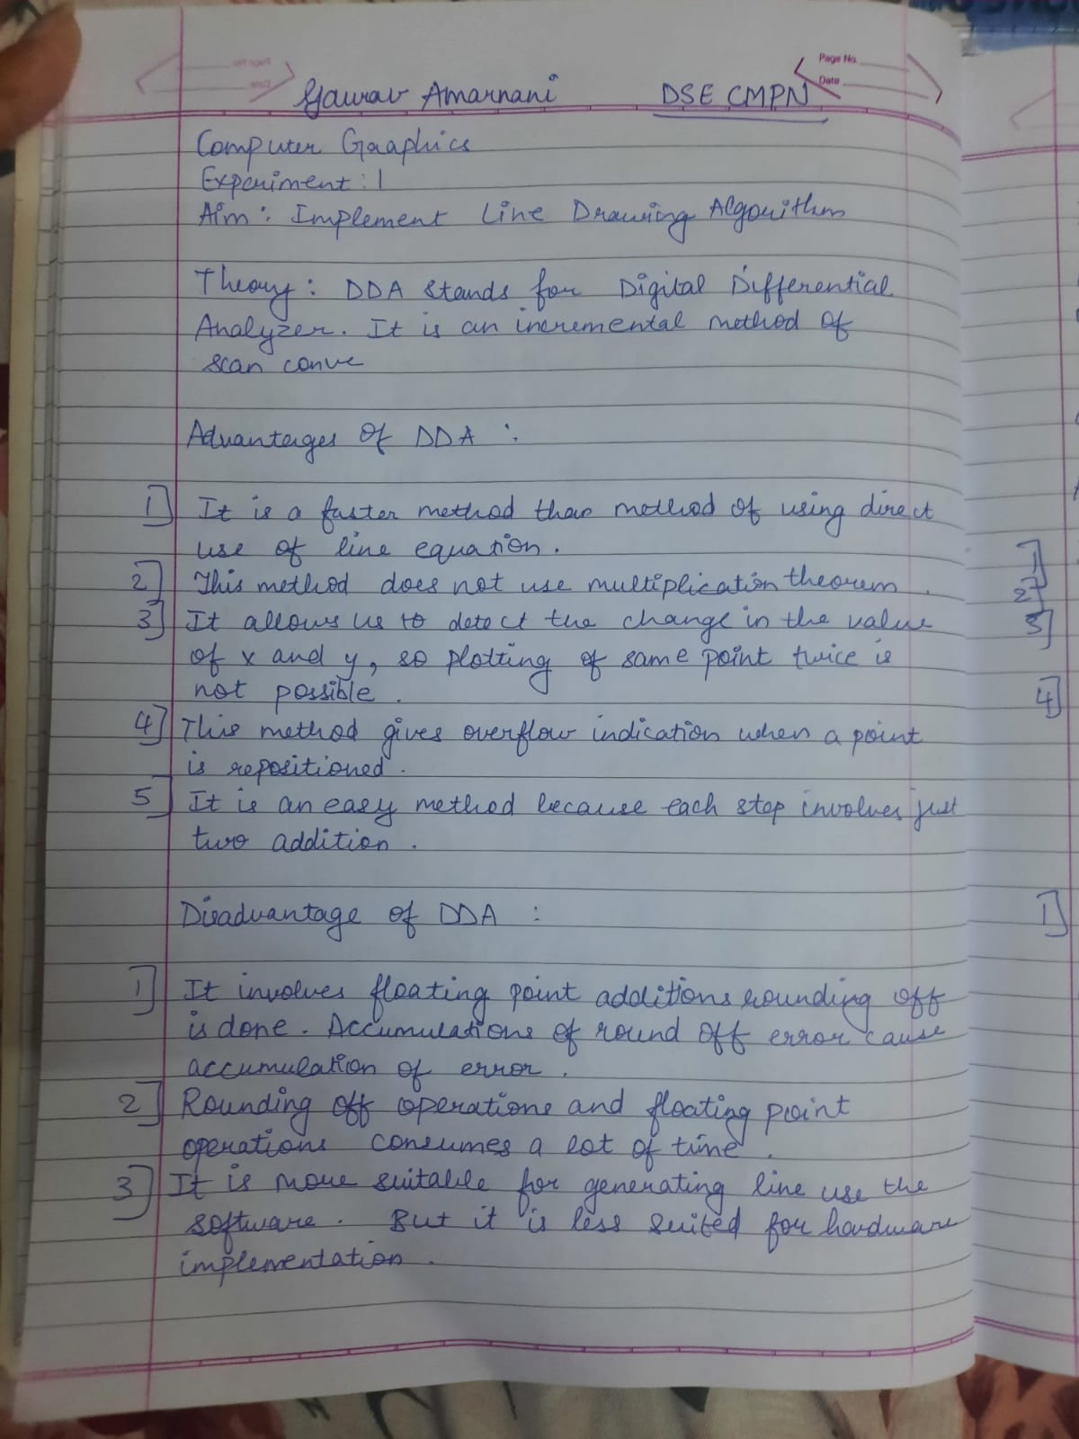

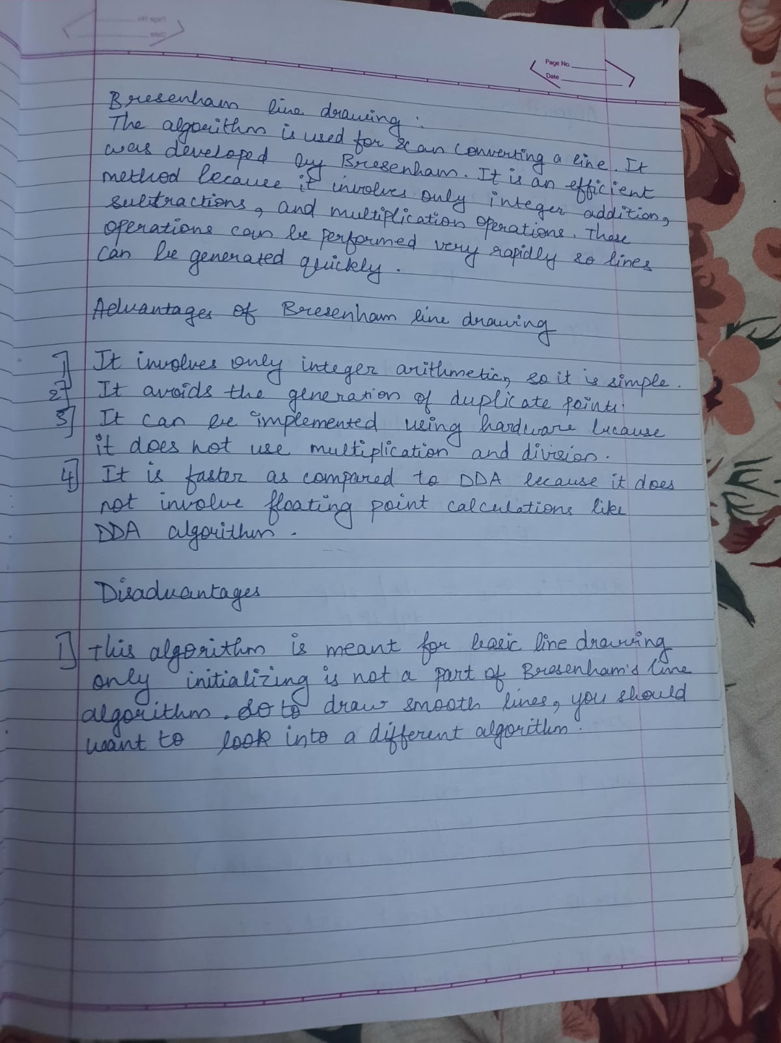

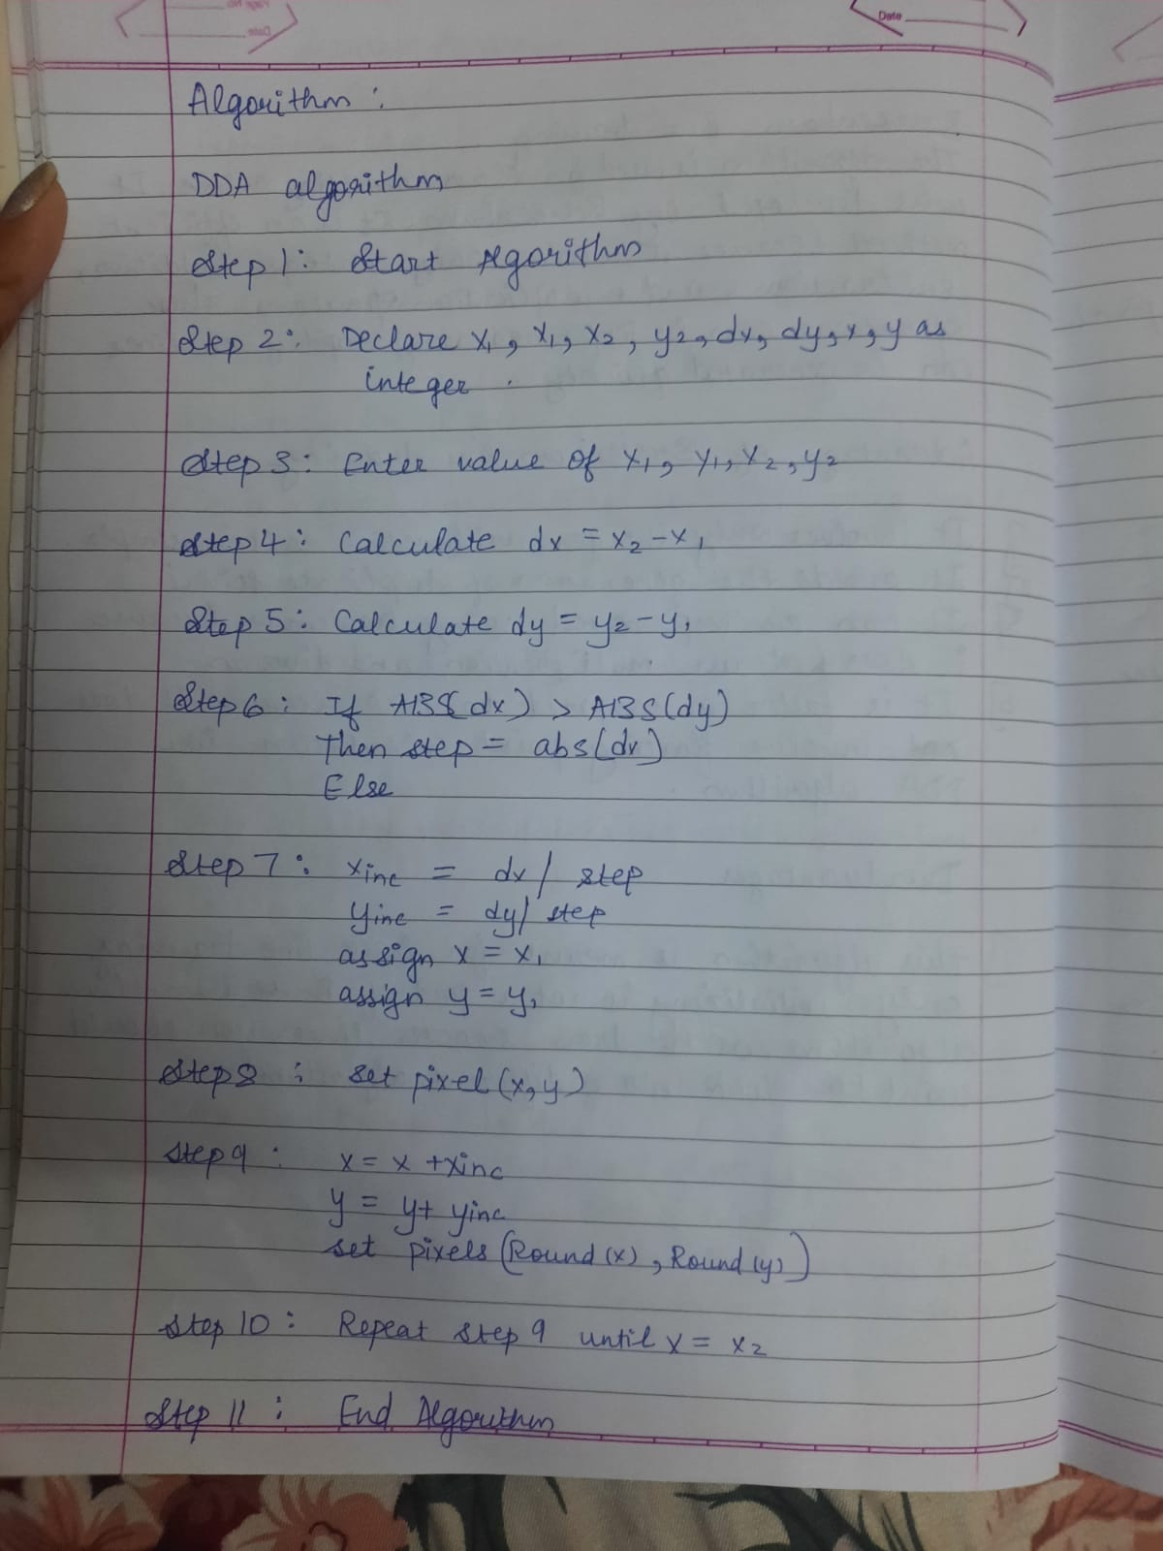

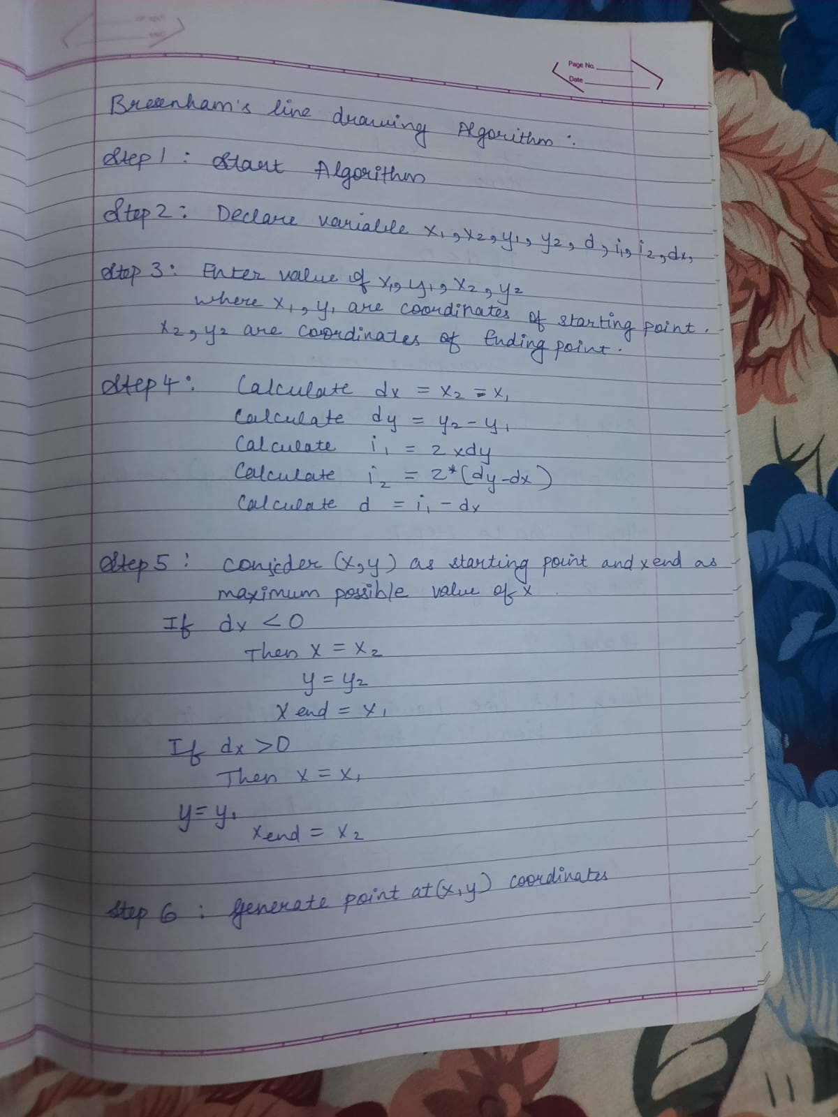

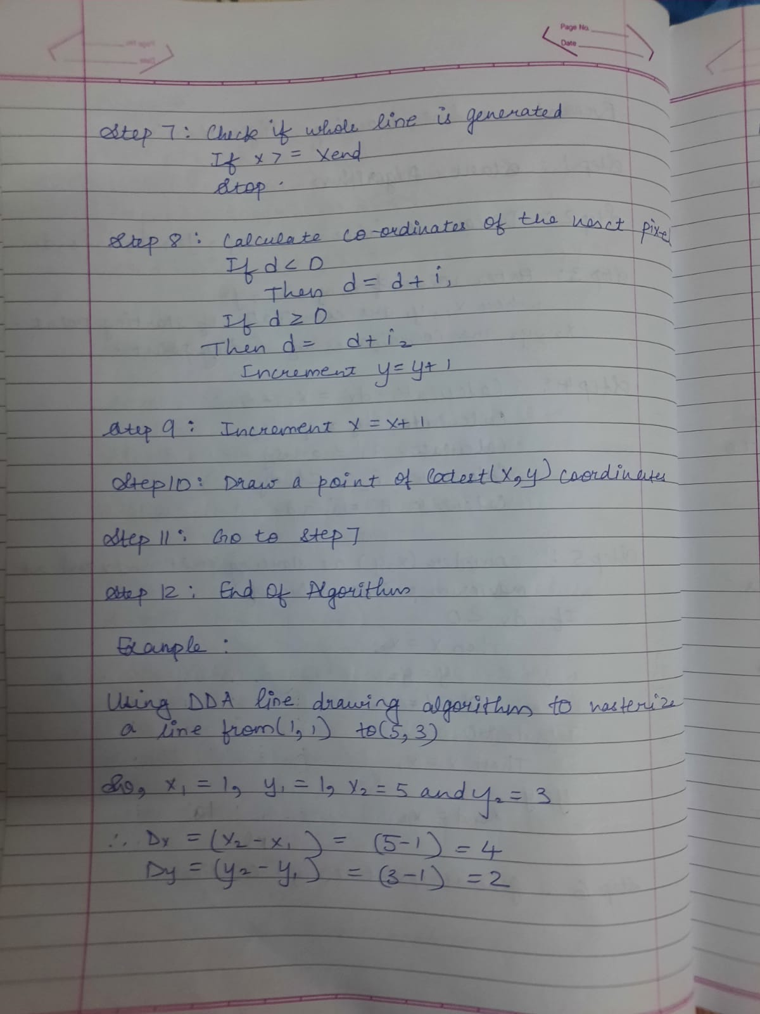

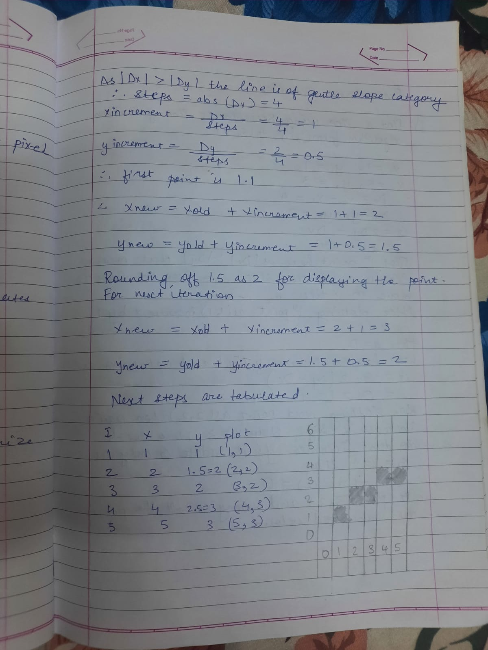

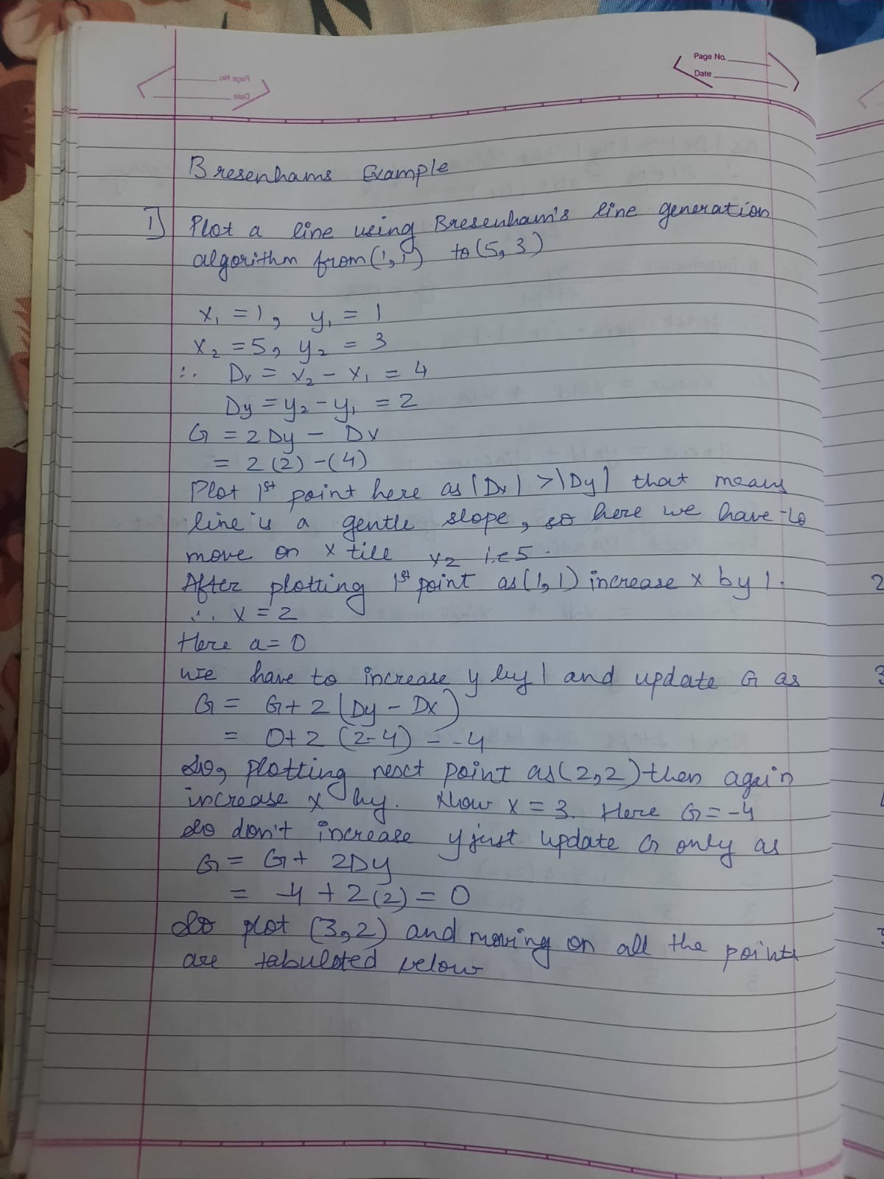

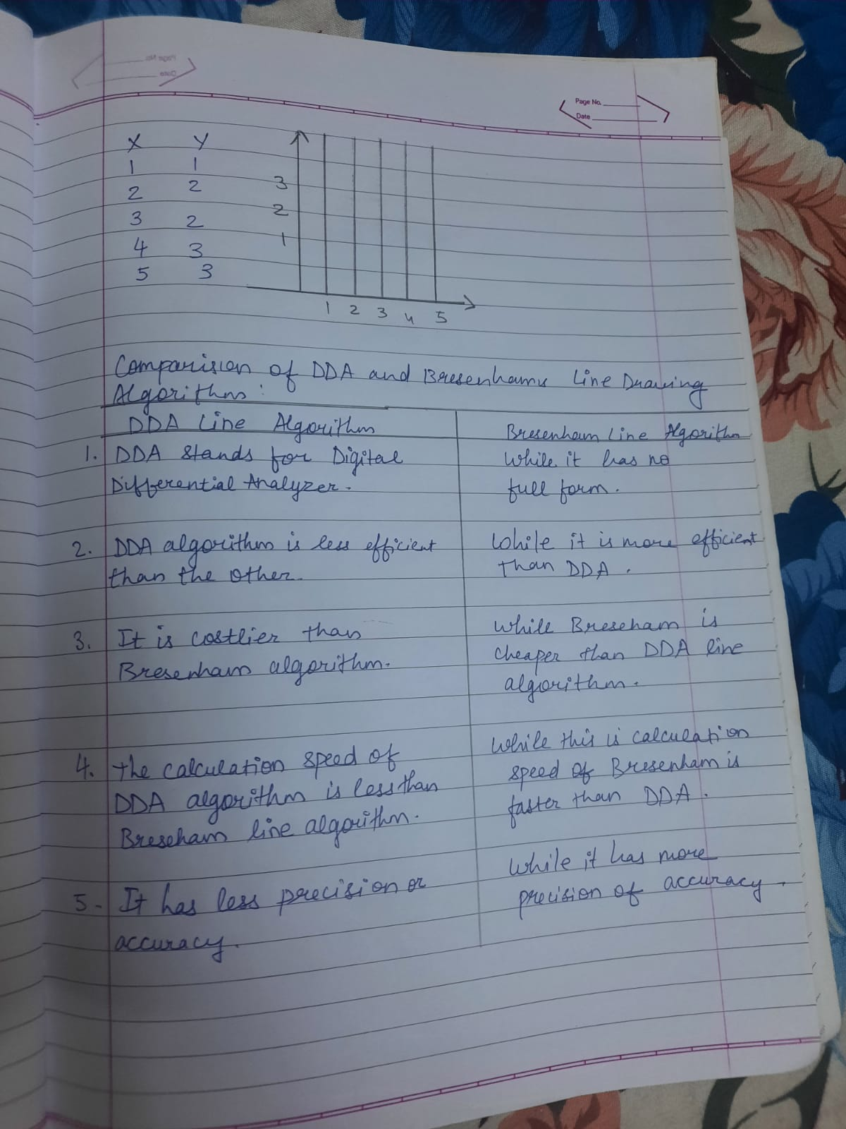

PROGRAM:

#include<stdio.h>
#include<graphics.h>
#include <stdlib.h>
#include<math.h>

//Performed by Gaurav Amarnani DSE CMPN.

void bresenham(int X0, int Y0, int X1, int Y1){
int dx=abs(X1-X0);
int dy=abs(Y1-Y0);
int x=X0, y=Y0, i=1;
int e=2*dy-dx;
do{
putpixel(x,y,15);
while(e>=0){
y=y+1;
e=e-2*dy;
}
x=x+1;
e=e+2*dy;
i=i+1;
} while (i<=dx);
}

void dda(int X0, int Y0, int X1, int Y1) {
int dx = X1 - X0;
int dy = Y1 - Y0;

int steps = abs(dx) > abs(dy) ? abs(dx) : abs(dy);

float Xinc = dx / (float) steps;
float Yinc = dy / (float) steps;
float X = X0;
float Y = Y0;

int i;
for (i = 0; i <= steps; i++) {
putpixel(X,Y,WHITE);
X += Xinc;
Y += Yinc;
}
}

void main() {
int gd = DETECT, gm,ch,x1,y1,x2,y2;

initgraph (&gd, &gm, "c:\\turboc3\\bgi");

printf("1. DDA. \n 2. BRESENHAM. \n 3. Exit.");
scanf("%d",&ch);
printf("Enter x1, y1, x2, y2:");
scanf("%d%d%d%d",&x1,&y1,&x2,&y2);

switch(ch){
case 1:
dda(x1, y1, x2, y2);
printf("Performed by Gaurav Amarnani DSE CMPN.");
break;
case 2:
bresenham(x1, y1, x2, y2);
printf("Performed by Gaurav Amarnani DSE CMPN.");
break;
case 3:
printf("Performed by Gaurav Amarnani DSE CMPN.");
exit(0);
default:
printf("Wrong Input.\n Performed by Gaurav Amarnani DSE CMPN.");
exit(0);
}
getch();
}

OUTPUT:

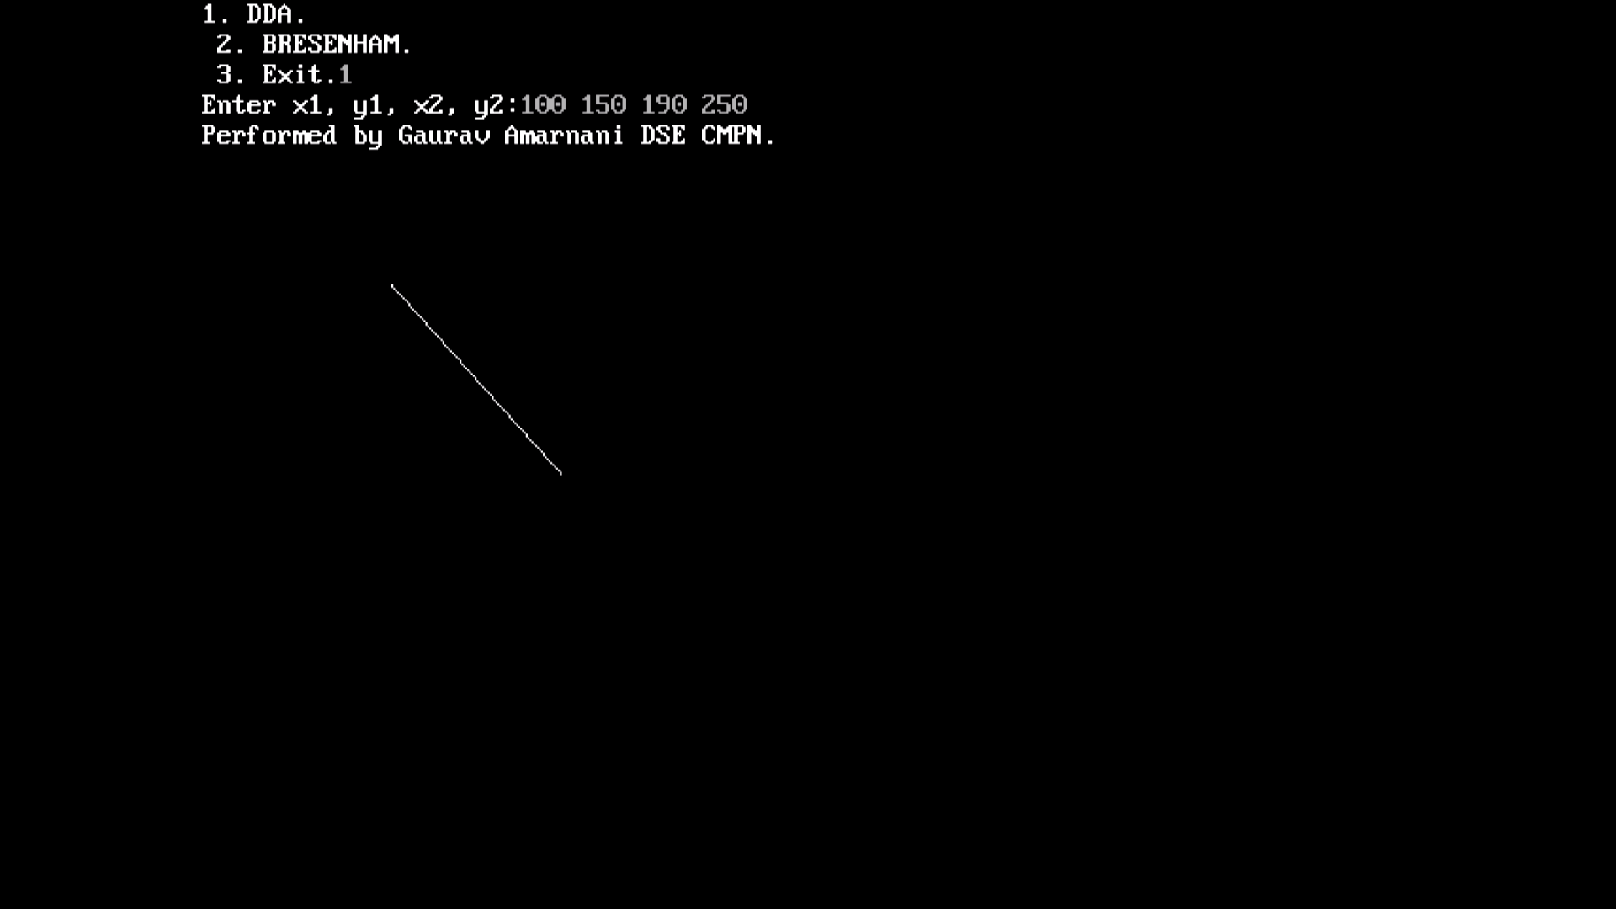

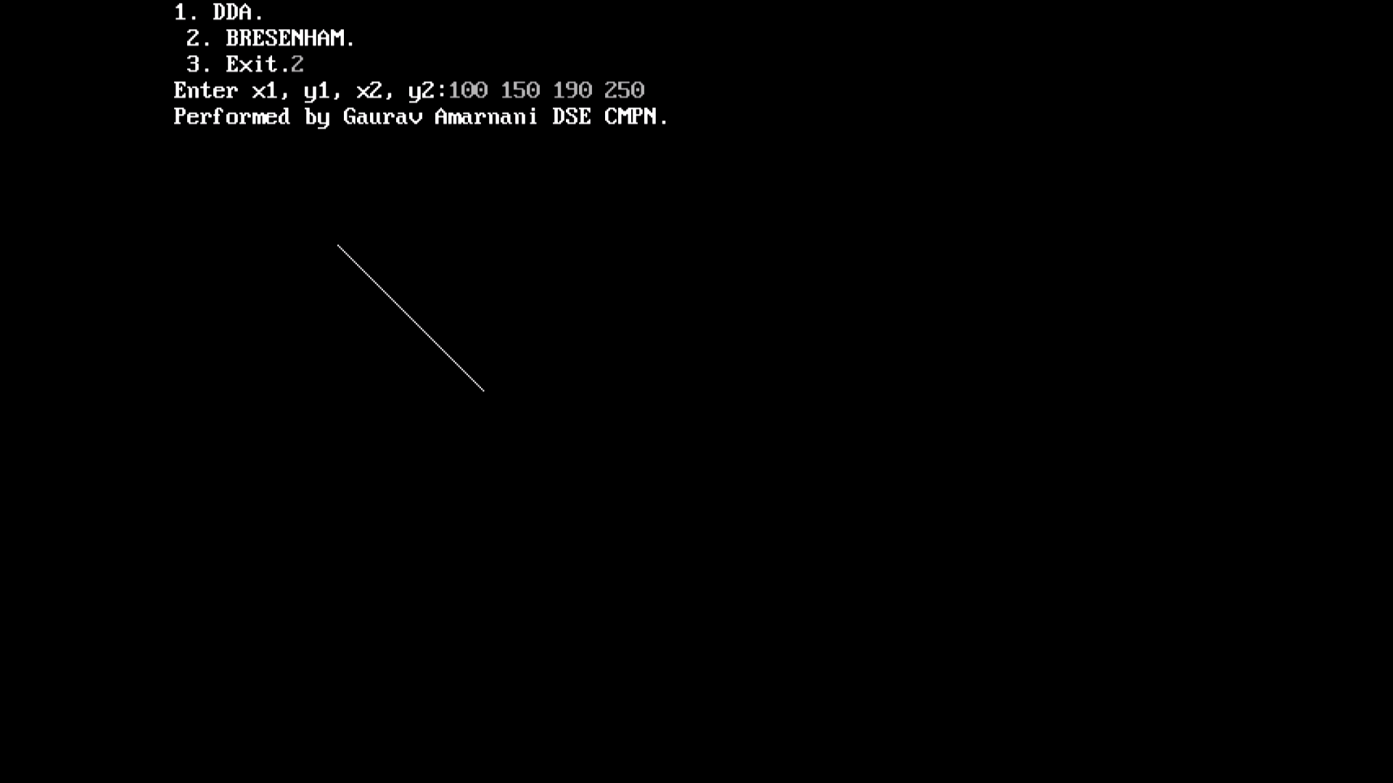

CONCLUSION:

